SUPPLIES NEEDED FOR SYLVIA’s STORE BACKPACKS – 2024

*Please note:
This is a very specific list. Please bring items from this list only. Sylvia has limited space and has already collected some items (ie, pencils, pens, markers). Pictures are to help explain what an item is; items do not need to be these same brands/colors.

If you have any questions, please contact Robin Abeshaus: robinabeshaus@gmail.com or Beth Rothermel: brothermel@gmail.com

FOLDERS / BINDERS / NOTEBOOKS:

- 2-pocket folders with prongs
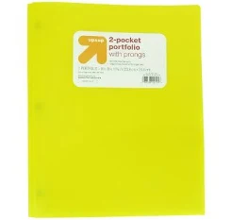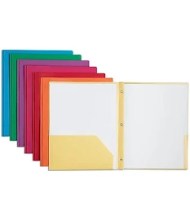

- 3-ring binders: 1 inch
**Please make sure the binders are 1-inch binders; teachers are particular about this and Sylvia cannot give out larger binders.
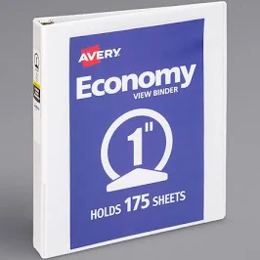

- Marbled Composition Books
(any color; must be marbled smaller size: 7.5” x 9.75”)
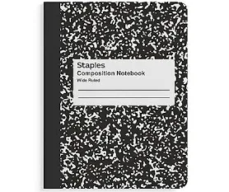

PAPER:

- Packages of loose-leaf paper: either college or wide ruled
- Reams of copy paper
- Packages of graph paper
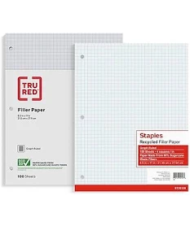

PENCILS / ERASERS / PENCIL BOXES:

- Pencil pouches – soft sided
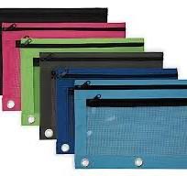

- Pencil Boxes – hard sided
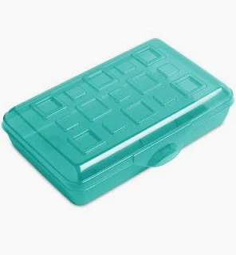
- Pencil Cap Erasers
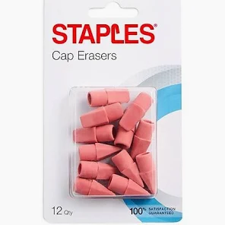

SCISSORS/GLUE:
- Glue Sticks
- 4 ounce bottles of glue

- 7-inch scissors: (Please note: these are larger scissors for older students; Sylvia already has elementary school scissors)
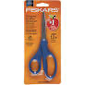

MARKERS:

- Dry-Erase Chisel Point (wide tip) Markers
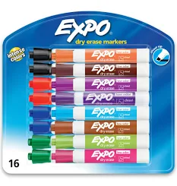

- Black Sharpie Markers -fine point
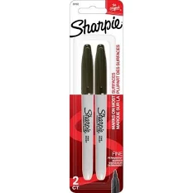

OTHER:
- Boxes of Kleenex
- Re-useable Water Bottles

